# HCL INTERNSHIP

## NAME: ANEM PRITAM

## GUIDE NAME: Dr. Rajashree

## Project Title: Rainfall Prediction

## Flow chart

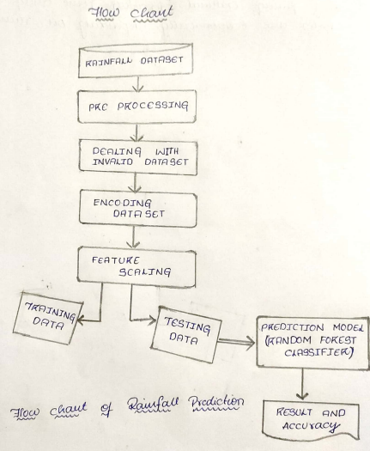

## ABSTRACT

